YARD DUTY AND SUPERVISION POLICY

PURPOSE

To ensure school staff understand their supervision and yard duty responsibilities.
The principal is responsible for ensuring that there is a well-organised and responsive system of supervision in place during school hours, before and after school, and on school excursions and camps.
This policy applies to all teaching and non-teaching staff at Devon Meadows Primary School, including education support staff, casual relief teachers and visiting teachers.
School staff are responsible for following reasonable and lawful instructions from the principal, including instructions to provide supervision to students at specific dates, time and places.

GUIDELINES

Devon Meadows Primary School’s grounds are supervised by school staff from 8:45am until 3:45pm. Outside of these hours, school staff will not be available to supervise students.
Parents and carers should not allow their children to attend Devon Meadows Primary School outside of these hours. Families are encouraged to contact the school for more information about the before and after school care facilities available to our school community.
If a student arrives at school before supervision commences at the beginning of the day, the principal or nominee staff member will, as soon as practicable, follow up with the parent/carer to:
- advise of the supervision arrangements before school
- request that the parent/ carer make alternate arrangements.
If a student is not collected before supervision finishes at the end of the day, the principal or nominee staff member will consider whether it is appropriate to:
- attempt to contact the parents/carers
- attempt to contact the emergency contacts
- place the student in an out of school hours care program (if available)
- contact Victoria Police and/or the Department of Health and Human Services (Child Protection) to arrange for the supervision, care and protection of the student.
School staff who are rostered on for before or after school supervision must follow the processes outlined below.

Yard duty
All staff at Devon Meadows Primary School are expected to assist with yard duty supervision and will be included in the weekly roster.
The principal or alternative nominee is responsible for preparing and communicating the yard duty roster on a regular basis. At Devon Meadows Primary School, school staff will be designated a specific yard duty area to supervise.
The designated yard duty areas for our school as at 29/01/2019 are:
Zone | Area
Zone 1 | Oval
Zone 2 | Buildings

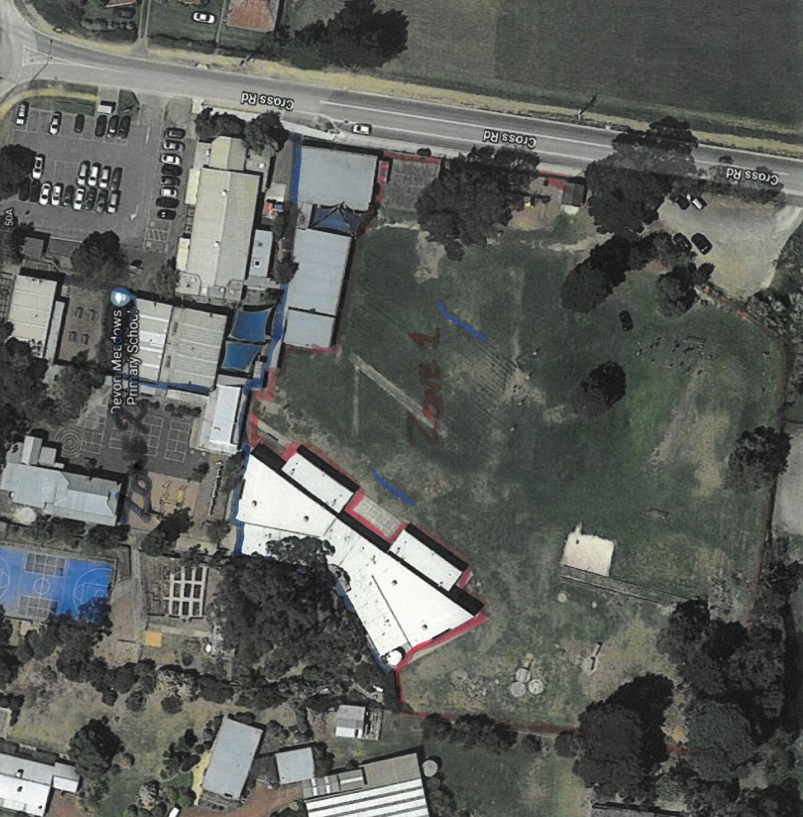

School staff must wear a provided safety/hi-vis vest and carry a yard duty bum bag whilst on yard duty. Safety/hi-vis vests will be stored staffroom.
Staff who are rostered for yard duty must remain in the designated area until they are replaced by a relieving teacher.
During yard duty, supervising staff must:
- methodically move around the designated zone
- be alert and vigilant
- intervene immediately if potentially dangerous or inappropriate behaviour is observed in the yard
- enforce behavioural standards and implement appropriate consequences for breaches of safety rules, in accordance with any relevant disciplinary measures set out in your school’s Student Engagement and Wellbeing policy
- ensure that students who require first aid assistance receive it as soon as practicable
- log any incidents or near misses as appropriate on Compass
- if being relieved of their yard duty shift by another staff member (for example, where the shift is ‘split’ into 2 consecutive time periods), ensure that a brief but adequate verbal ‘handover’ is given to the next staff member in relation to any issues which may have arisen during the first shift.
If the supervising staff member is unable to conduct yard duty at the designated time, they should contact the Principal or Assistant Principal] with as much notice as possible prior to the relevant yard duty shift to ensure that alternative arrangements are made.
If the supervising staff member needs to leave yard duty during the allocated time, they should contact the Principal or Assistant Principal] but should not leave the designated area until the relieving staff member has arrived in the designated area.
If a relieving or next staff member does not arrive for yard duty, the staff member currently on duty should contact the office and not leave the designated area until a replacement staff member has arrived.
Should students require assistance during recess or lunchtime, they are encouraged to speak to the supervising yard duty staff member.

Classroom
The classroom teacher is responsible for the supervision of all students in their care during class.
If a teacher needs to leave the classroom unattended at any time during a lesson, they should first contact the office for assistance. The teacher should then wait until another staff member has arrived at the classroom to supervise the class prior to leaving.

School activities, camps and excursions
The principal and leadership team are responsible for ensuring that students are appropriately supervised during all school activities, camps and excursions, including when external providers are engaged to conduct part or all of the activities. Appropriate supervision will be planned for special school activities, camps and excursions on an individual basis, depending on the activities to be undertaken and the level of potential risk involved.

EVALUATION

All policies will be reviewed as part of the school’s cyclic review process. This policy will be reviewed in June 2021.

COUNCIL APPROVED: ______________________

DATE: ______________________

